**GCP – HOL -Session 1**

In the GCP Console, on the project selector page, click **Create** to begin creating a new GCP project.

[GO TO THE PROJECT SELECTOR PAGE](https://console.cloud.google.com/projectselector2/home/dashboard)

Start Cloud Shell

Click the **Activate Cloud Shell** button at the top of the console window.

Activate Cloud Shell

A Cloud Shell session opens inside a new frame at the bottom of the console and displays a command-line prompt. It can take a few seconds for the shell session to be initialized.

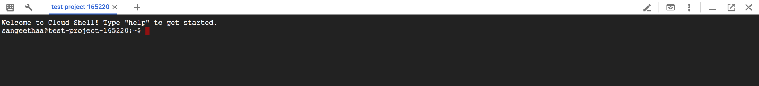

Your Cloud Shell session is ready to use.

Use the command line

You can now use the pre-installed [gcloud command-line tool](https://cloud.google.com/sdk/gcloud).

When you start Cloud Shell, the active project in Console is propagated to your gcloud configuration inside Cloud Shell. If you'd like to switch between configurations, find out more [here](https://cloud.google.com/sdk/docs/configurations#activating_a_configuration).

Run the gcloud version command to try the gcloud command-line tool from within the Cloud Shell session:

gcloud version

This will display a list of installed Cloud SDK components and their versions:

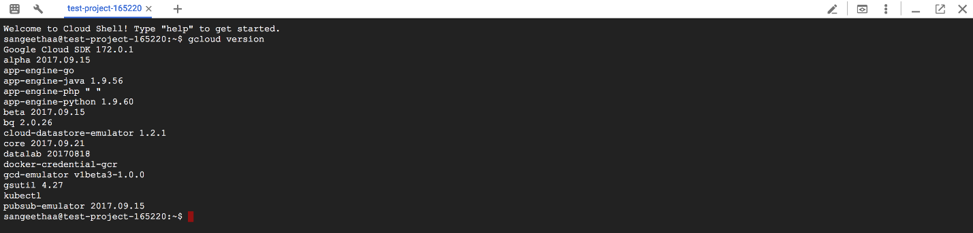

Use your home directory

Try out your home directory:

1. Change your current working directory:

cd $HOME

1. Open your .bashrc configuration file using vi.

vi ./.bashrc

The editor opens and displays the contents of the file.

1. Press the ESC key and then q! to exit the editor.

The contents of your Cloud Shell home directory persist across projects between all Cloud Shell sessions, even after the virtual machine terminates and is restarted.

Preview and deploy an App Engine application

Use web preview to preview an App Engine app before you deploy it:

1. Clone a sample app and run it locally in the Cloud Shell session using the App Engine development server.

git clone https://github.com/GoogleCloudPlatform/appengine-guestbook-python \  
    && cd appengine-guestbook-python \  
    && dev_appserver.py ./app.yaml

1. Click the **Web Preview** button Web Preview Button and then select the port number from the displayed menu.

Cloud Shell opens the preview URL on its proxy service in a new browser window.

1. When you are done previewing the App Engine app, type **Ctrl + C** to stop the development server.
2. Deploy the app to App Engine:

gcloud app deploy ./index.yaml ./app.yaml

1. Open the application in your web browser. The URL is https://[PROJECT_ID].appspot.com/.

It may take a few minutes for deployment to complete. If the application is not fully deployed, you will see an error message in the web browser. Refresh the browser to see the deployed application.